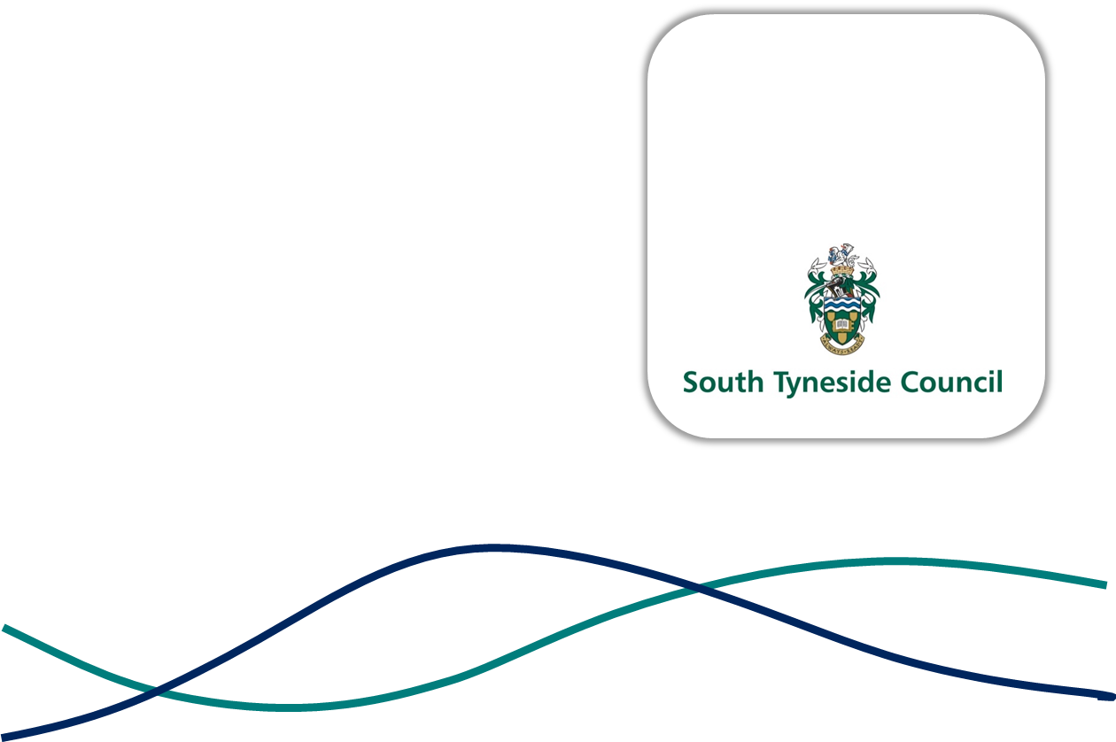

JOB DESCRIPTION

JOB TITLE: | ASSISTANT DIRECTOR OF LEGAL AND GOVERNANCE
GRADE: | ASSISTANT DIRECTOR 1
REPORTS TO: | DIRECTOR OF BUSINESS AND RESOURCES
DIRECT REPORTS: | HEAD OF LEGAL AND GOVERNANCE (DEPUTY MONITORING OFFICER)  INFORMATION GOVERNANCE AND FEEDBACK MANAGER  CIVIC AND MEMBERS SUPPORT MANAGER
DATE: | JULY 2026

PURPOSE

This is a pivotal role in the Council’s Corporate Leadership Team, reporting to the Director of Business and Resources and supporting Elected Members, providing strategic leadership to the Legal and Democratic Services teams as well as fulfilling all responsibilities as Monitoring Officer.

This is a key role in delivering our overarching vision “Making Our South Tyneside - A place where people live healthy, happy, and fulfilled lives.”

The post holder will work directly with the Chief Executive and Director of Business and Resources overseeing the business of the Council, providing strategic and operational leadership on democratic and legal affairs to ensure the business and day-to-day operations of the Council run effectively, in line with policies and strategic plans agreed with Elected Members.

As well as the Legal and Democratic Service teams, the post holder will also provide leadership and management oversight for the Council’s Information Governance, Records Management, and Civic and Members Support teams.

The post holder will be a member of the Council’s Corporate Leadership Team who advises the Leader of the Council, Cabinet, and all Elected Members.

The post holder will act as the Monitoring Officer for the Council. The Monitoring Officer has three main roles:
- To report on matters they believe are, or are likely to be illegal, or amount to maladministration.
- To be responsible for matters relating to the conduct of Elected Members and officers and
- To be responsible for the operation of the Constitution.

The Monitoring Officer also has responsibility for monitoring and reviewing the operation of the Constitution, to ensure that the aims and principles of it are given full effect. In addition, the Monitoring Officer is responsible for matters of interpretation of the Constitution Rules and Procedures and for making a determination on these if necessary.

KEY RESPONSIBILITIES

- Lead a high-quality Legal and Democratic service delivering a broad range of governance to the Council.

- Ensure the Council’s statutory requirements and democratic processes, including registrars and elections, are delivered efficiently and effectively, and the Council’s activities are conducted in a lawful and transparent manner.

- Fulfil all the statutory Monitoring Officer duties and responsibilities, including reporting on matters the postholder believes are, or likely to be illegal, or amount to maladministration; be responsible for matters relating to the conduct of Elected Members and officers; and be responsible for the operation of the Constitution.

- Responsible for monitoring and reviewing the operation of the Constitution, to ensure that the aims and principles are given full effect.

- Responsible for matters of interpretation of the Constitution Rules and Procedures and for making a determination on these if necessary.

- Manage relationships and provide advice and support to the Leader and Chief Executive in engaging with Government and national bodies such as the Local Government Association.

- Ensure a coordinated and strategic approach to the Council’s regional and national affairs, including identifying new opportunities for external engagement.

- Maintain a comprehensive overview of current local, regional, and national affairs, policy, and governance – advising on priorities, opportunities, and positioning.

- Support the Chief Executive, Directors, and Lead Members in the development and delivery of the overall strategic vision for the Council.

- Ensure the core business priorities of the Council are delivered efficiently and effectively, enabling the Council’s Chief Executive and Leadership to fulfil their broad range of external and internal commitments.

- Ensure the smooth and effective interface between the senior political and senior officer executive functions of the Council, building on the existing strong Officer/ Member relationships.

- Provide oversight of Standards Committee functioning through effective liaising with the Independent Chair.

- Accountable for the coordination and delivery of strategic projects and commitments, requiring a robust understanding of the full breadth of strategic and operational priorities of the Council and having oversight of all cross-cutting issues.

- Accountability for the oversight of critical meetings and events and ensuring appropriate prioritisation, focus, and resource allocation.

- Represent the Council and senior officer team as appropriate, internally, and externally.

- Provide corporate advice and direction to senior officers across the Council and close partners.

- Embody the Council’s PROUD values through behaviours and decision-making, setting direction, establishing priorities, building capacity, maintaining focus and alignment, and delivering value for money and continuous improvement.

- Drive and lead change, setting exceptionally high standards, and motivating others to deliver the best public services for the residents of South Tyneside.

- Work with Corporate Leadership Team and Extended Leadership Team to set and deliver the Council’s strategic direction and priorities. Fully contribute to the identification and formulation of strategic objectives for the Council, ensuring that appropriate plans are adopted and that decisions are effectively implemented that secure future prosperity.

- Lead key corporate programmes, strategies, policies, and initiatives and contribute to corporate teams tackling cross-cutting issues.

- Makes a significant and demonstrable contribution to the Council’s strategic priorities through a mix of innovative and exciting marketing, communications, and public relations approaches.

- Act as a representative for the Chief Executive and Corporate Leadership Team.

- Provide support to the Principal Advisor and Lead Chief Executive to Newcastle International Airport Board and Chair of LA7 supporting effective relationships with both shareholders and stakeholders.

- Provide leadership and management oversight for the Council’s Legal and Governance service.

- Provide leadership and management oversight for the Council’s Information Governance and Records Management service.

- Provide leadership and management oversight for the Civic and Members Support Service, including Civic Events.

FURTHER DETAIL

Everything we do is underpinned by our PROUD values and guiding behaviours. You can find more details about these here:

Our Council Values and Behaviours - South Tyneside Council

