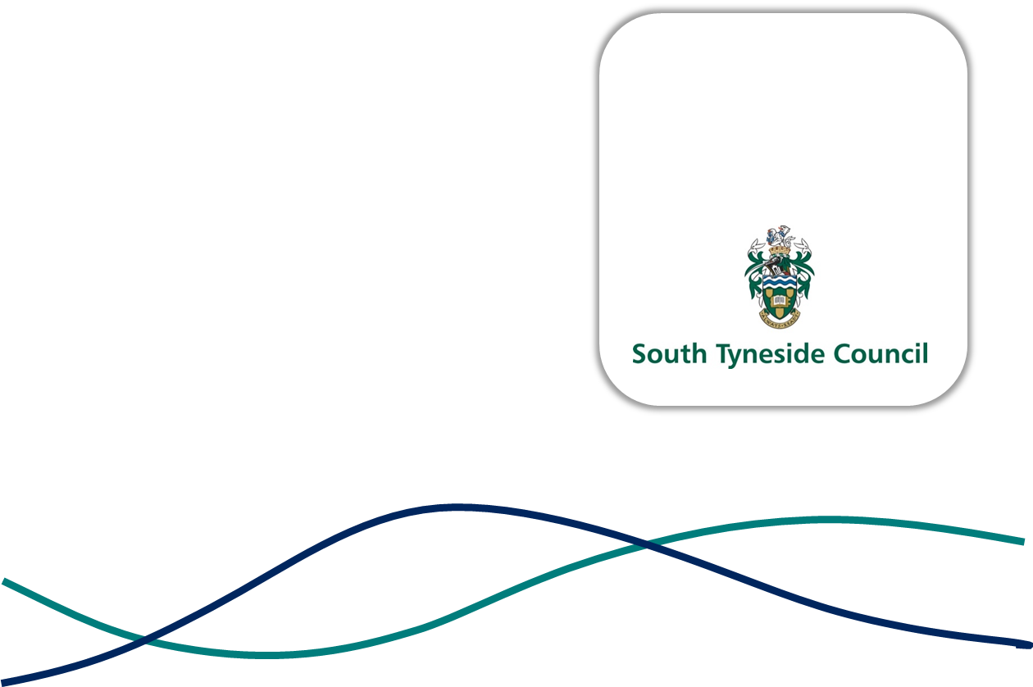

PERSON SPECIFICATION

JOB TITLE: | ASSISTANT DIRECTOR OF LEGAL AND GOVERNANCE
GRADE: | ASSISTANT DIRECTOR 1
REPORT TO: | DIRECTOR OF BUSINESS AND RESOURCES
DIRECT REPORTS: | HEAD OF LEGAL AND GOVERNANCE (DEPUTY MONITORING OFFICER)  INFORMATION GOVERNANCE AND FEEDBACK MANAGER  CIVIC AND MEMBERS SUPPORT MANAGER
DATE: | JUNE 2026

EXPERIENCE & SKILLS

- Substantial experience of operating at a senior level within a large corporate organisation, providing robust and sound advice to key decision makers on a range of complex and critical issues.

- Thorough understanding of the local government operating environment, with comprehensive knowledge of the Council’s Constitution, governance arrangements and decision-making procedures.

- Extensive knowledge and understanding of local, regional and national affairs, policy and governance.

- Professionally qualified Lawyer with an in depth understanding of Local and Regional Government statutory duties.

- Successful track record of leading and delivering change through others, with strong advisory and influencing skills.

- Highly developed communication and relationship management skills and the ability to represent the Council’s Leadership in a variety of formal and informal settings.

- Highly developed political awareness and understanding and experience of making decisions and getting things done within a complex public service environment.

- Demonstrable knowledge and experience of organisational and political process with an ability to work with agility across a broad range of high-profile matters whilst maintaining a clear sense of purpose.

- A proven track record of successfully operating within varying degrees of ambiguity in a fast-paced environment and the ability to deal with and satisfactorily resolve conflict and achieve resolution.

- Strong strategic thinking capability, supported by excellent policy development skills and a sound understanding of performance and financial management.

- Able to provide clear and balanced advice on strategic issues that achieve the corporate, strategic and operational priorities of the organisation.

- Able to negotiate at a senior level and experience of presenting at Board level and engaging with external partners.

- Able to act as a senior ambassador of the Council embodying the Council’s PROUD values.

- Strong decision maker, with a positive and open-minded approach.

- Proactively takes ownership for issues and is highly resilient with the ability to work under pressure and deliver to tight deadlines.

- Experience of working with Corporate Leadership Team to set and deliver the Council’s strategic direction and priorities.

- Experience of leading key corporate programmes, strategies, policies and initiatives and contributing to corporate teams tackling cross-cutting issues.

- Able to make a significant and demonstrable contribution to the Council’s strategic priorities through a mix of innovative and exciting marketing, communications and public relations approaches.

Personal Style and Behaviour
- An individual who is seeking significant career challenge with the drive to succeed in this important and challenging role.

- A commitment to the Council’s Vision and PROUD values and behaviours

- Committed to the promotion of Equality, Diversity, Inclusion and Belonging (EDIB) in everything that we do.

- Consistently demonstrates the highest level of professionalism and integrity.

- Personal and professional demeanour and credibility which commands the confidence of
Elected Members, senior managers, staff, external partners and other stakeholders.

- A strategic thinker who acts and thinks corporately with a collaborative style that empowers others.

- Leads by example, delivers without supervision and is confident in own ability to make sound decisions.

- Motivated, resilient and not easily discouraged.

- Behaviours outside of work commensurate with the seniority of the role and its regional standing.

